Agenda Item : 2/03

= application site



Stonegrove Gardens, HA8 7TF | P/1571/18

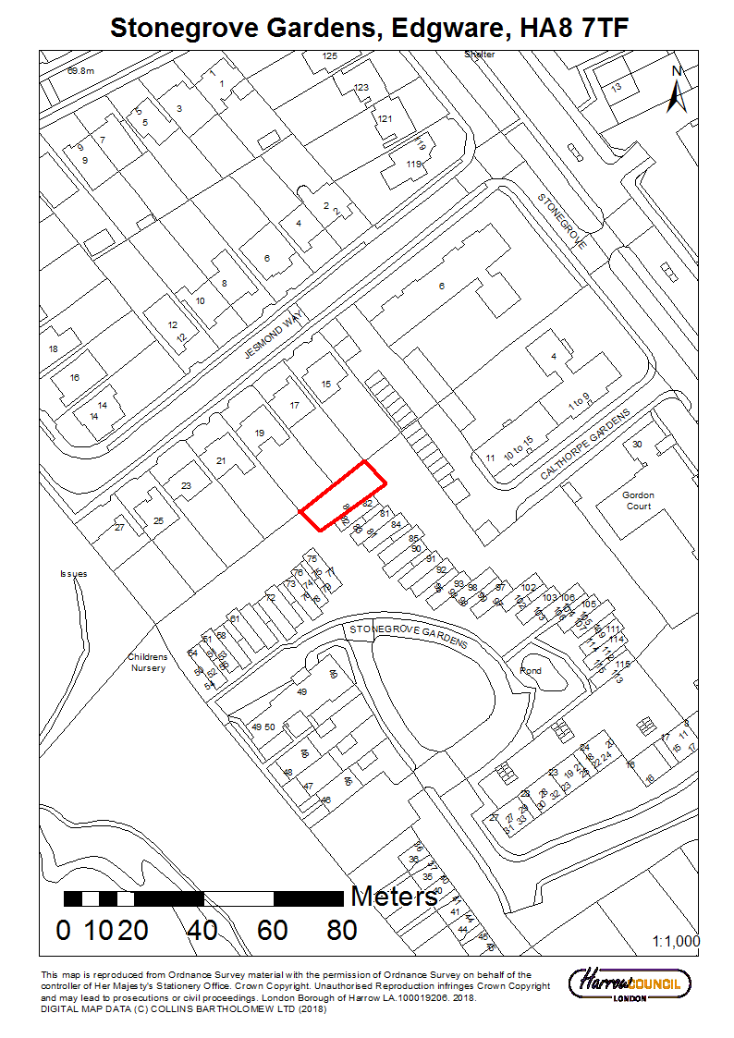
Stonegrove Gardens, HA8 7TF | P/1571/18
LONDON BOROUGH OF HARROW

PLANNING COMMITTEE

21st November 2018

APPLICATION NUMBER: | P/1571/18
VALIDATE DATE: | 27TH APRIL 2018
LOCATION: | STONEGROVE GARDENS, EDGWARE
WARD: | CANONS
POSTCODE: | HA8 7TF
APPLICANT: | LONDON BOROUGH OF HARROW
AGENT: | INGLETON WOOD
CASE OFFICER: | NABEEL KASMANI
EXTENDED EXPIRY DATE: | 23/11/2018

PROPOSAL

Re-development to provide a two storey building for two flats; private and communal amenity space; landscaping; bin / cycle storage

RECOMMENDATION

The Planning Committee is asked to:

- agree the reasons for approval as set out in this report, and

- grant planning permission subject to the conditions listed in Appendix 1 of this report:

REASON FOR THE RECOMMENDATIONS

The proposed development would bring forward housing provision of a satisfactory mix, layout and design to ensure that the future occupiers would benefit from a high standard of living accommodation. It is considered that the proposed building would have an acceptable design and external appearance and would not have an undue impact on the character and appearance of the area or the residential amenity of neighbouring occupiers

INFORMATION

This application is reported to Planning Committee as the proposed development is on land owned by the Council and would create over 100m² floor space. The proposal therefore falls outside Schedule 1 of the Scheme of Delegation.

Statutory Return Type: | (E)13 Minor Dwellings
Council Interest: | Yes – The Council is the landowner and applicant
GLA Community Infrastructure Levy (CIL) Contribution: | £4,270
Local CIL requirement: | £13,420

HUMAN RIGHTS ACT

The provisions of the Human Rights Act 1998 have been taken into account in the processing of the application and the preparation of this report.

EQUALITIES

In determining this application the Council has regard to its equalities obligations including its obligations under section 149 of the Equality Act 2010.

For the purposes of this application there are no adverse equalities issues.

S17 Crime & Disorder Act

Policies 7.3.B and 7.13.B of The London Plan and Policy DM1 of the Development Management Polices Local Plan require all new developments to have regard to safety and the measures to reduce crime in the design of development proposal. It is considered that the proposed access does not adversely affect crime risk.

LOCAL GOVERNMENT (ACCESS TO INFORMATION) ACT 1985
BACKGROUND PAPERS USED IN PREPARING THIS REPORT:

- Planning Application
- Statutory Register of Planning Decisions
- Correspondence with Adjoining Occupiers
- Correspondence with Statutory Bodies
- Correspondence with other Council Departments
- Nation Planning Policy Framework
- London Plan
- Local Plan - Core Strategy, Development Management Policies, SPGs
- Other relevant guidance

LIST OF ENCLOSURES / APPENDICES:

Officer Report:
Part 1: Planning Application Fact Sheet
Part 2: Officer Assessment
Appendix 1 – Conditions and Informatives
Appendix 2 – Site Plan
Appendix 3 – Site Photographs
Appendix 4 – Plans and Elevations

OFFICER REPORT

PART 1: Planning Application Fact Sheet

The Site

Address | Stonegrove Gardens, Edgware, HA8 7TF
Applicant | London Borough of Harrow
Ward | Canons
Local Plan allocation | n/a
Conservation Area | n/a
Listed Building | n/a
Setting of Listed Building | n/a
Building of Local Interest | n/a
Tree Preservation Order | n/a
Flood Zone | EA Flood Zone 1,
Other | Critical Drainage Area

Housing

Density | Proposed Density hr/ha | 200hr/ha
Density | Proposed Density u/ha | 100u/ha
Density | PTAL | 1b
Density | London Plan Density Range | 150–250 hr/ha  50-95 u/ha
Dwelling Mix | 2 bed, 3 person | 2

Transportation

Car parking | No. Existing Car Parking spaces | 0
Car parking | No. Proposed Car Parking spaces | 0
Cycle Parking | No. Existing Cycle Parking spaces | 0
Cycle Parking | No. Proposed Cycle Parking spaces (residential use) | 2
Public Transport | PTAL Rating | 1b
Public Transport | Closest Rail Station / Distance | 0.84 miles
Public Transport | Bus Routes | 142 (250m away)
Parking Controls | Controlled Parking Zone | n/a
Parking Controls | CPZ Hours | n/a
Parking Controls | Other on-street controls | Double Yellow lines for part of Stonegrove Gardens
Refuse/Recycling Collection | Summary of proposed refuse/recycling strategy | Designated refuse store within the site
PART 2: Assessment

- SITE DESCRIPTION

1.1 The application site consists of a rectangular parcel of land to the north of no. 80-82 Stonegrove Gardens which currently features a redundant laundrette

1.2 Stonegrove Gardens is a residential estate characterised by two and three storey attached flats which have a rectangular form and feature a shallow pitched roof profile. No.80-82 Stonegrove Gardens adjoins the application site to the south. The application site abuts the rear gardens of nos. 15-21 Jesmond way to the west. A detached garage block is located beyond the communal garden to the north-east

1.3 There are two car parks and off-street parking capacity for the occupiers who own a motor vehicle. Refuse bins are provided for each flat and are generally located at the rear of the respective properties.

- PROPOSAL

2.1 The proposal seeks to demolish the existing laundry building and to construct a two-storey building to provide two x two bedroom flats.

2.2 The proposed building would follow the form and character of the existing adjacent buildings incorporating a flat roof and shallow pitch roof. It would have a width of 5.5m, depth of 16m and maximum height of 6.8m.

2.3 The proposal would include a mix of hard and soft landscaping. Designated bin and cycle storage would be provided to the north of the proposed building.

- RELEVANT PLANNING HISTORY

3.1 There is no relevant planning history to the application

- CONSULTATION

4.1 A total of 10 consultation letters were sent to neighbouring properties regarding this application.

4.2 The initial public consultation period expired on 18th May 2018. Following submission of revised drawings, a reconsultation was undertaken which expired on 7th November 2018.

4.3 Adjoining Properties

Number of letters Sent | 10
Number of Responses Received | 0
Number in Support | 0
Number of Objections | 0
Number of other Representations (neither objecting or supporting) | 0

4.4 Statutory and Non Statutory Consultation

4.5 The following consultations have been undertaken.

LBH Highways

We have no objection to the principle of this proposal however, a suitable condition should be attached requiring details of the type of cycle storage to be provided (min. 2 spaces per unit).

LBH Drainage

No objection subject to conditions

- POLICIES

5.1 Section 38(6) of the Planning and Compulsory Purchase Act 2004 requires that:

‘If regard is to be had to the Development Plan for the purpose of any determination to be made under the Planning Acts, the determination must be made in accordance with the Plan unless material considerations indicate otherwise.’

5.2 The Government has issued the National Planning Policy Framework [NPPF] which consolidates national planning policy and is a material consideration in the determination of this application.

5.3 In this instance, the Development Plan comprises The London Plan 2016 [LP] and the Local Development Framework [LDF]. The LDF comprises The Harrow Core Strategy 2012 [CS], Harrow and Wealdstone Area Action Plan 2013 [AAP], the Development Management Policies Local Plan 2013 [DMP], the Site Allocations Local Plan [SALP] 2013 and Harrow Local Area Map 2013 [LAP].

5.4 While this application has been principally considered against the adopted London Plan (2016) policies, some regard has also been given to relevant policies in the Draft London Plan (2017), as this will eventually replace the current London Plan (2016) when adopted and forms part of the development plan for the Borough. Given that that the draft London Plan is still in the initial stages of the formal process it holds very limited weight in the determination of planning applications. Notwithstanding the above, the draft London Plan (2017) remains a material planning consideration, with relevant policies referenced within the report below and a summary within Informative 1.

5.5 A full list of all the policies used in the consideration of this application is provided as Informative 1 in Appendix 1 of this report.

6.0 ASSESSMENT

6.1 The main issues are;

  - Principle of the Development
  - Layout, Design, Character and Appearance
  - Housing Supply, Mix and Density
  - Residential Amenity
  - Transport and Parking
  - Flood Risk and Development

6.2 Principle of Development

6.2.1 Having regard to the planning designations on the site, there are no development plan policies that specifically preclude the provision of a residential use here. The site is considered to be previously developed as it would replace the existing laundry building and for this reason, the proposal would not constitute garden land development.

6.2.2 This site can be considered to be a windfall site for the provision of new housing insofar as it is not an identified site for development. The provision of housing on this site would contribute to the strategic vision of Policy 3.3 of The London Plan (2016) which recognises the need for more homes throughout Greater London and Policy CS1 of the Harrow Core Strategy (2012) with regards to the provision of additional housing within the borough.

6.2.3 The proposed residential use would be consistent with surrounding land use. The use of the land for residential uses could therefore be supported in principle and would make a contribution to the housing stock in the borough. For these reasons it is considered that the principle of the use of this site for the provision of housing is acceptable and would accord with the above policies, subject to consideration of further policy requirements as detailed below

6.3 Layout, Design, Character and Appearance

6.3.1 Chapter 12 of the NPPF states that Government attaches great importance to the design of the built environment. Good design is a key aspect of sustainable development, is indivisible from good planning, and should contribute positively to making places better for people. In determining applications, great weight should be given to outstanding or innovative designs which promote high levels of sustainability, or help raise the standard of design more generally in an area, so long as they fit in with the overall form and layout of their surroundings.

6.3.2 Good design is central to all objectives of the London Plan and is specifically promoted by the policies contained within Chapter seven, which address both general design principles and specific design issues. London Plan Policy 7.1 sets out a series of overarching design principles for development in London. Other relevant design policies in this chapter include specific design requirements relating to inclusive design; designing out crime; local character; public realm; architecture; tall and large scale buildings; and heritage assets.

6.3.3 Harrow’s Core Strategy Policy CS1 seeks to protect the character of Harrow’s suburbs and town centres. Policy DM1 on Achieving a High Standard of Development of the Development Management Policies Document requires all development proposals to achieve a high standard of design and layout. This assessment of the design and layout relates to the massing, bulk, scale and height of the proposed building; the appearance; context; space around buildings; the need to retain or enhance existing landscaping; the functionality of the development; the safe, sustainable and inclusive access.

6.3.4 The application site consists of a redundant laundrette building attached to the north-west of nos. 80-82 Stonegrove Gardens. The existing building would be replaced by a two-storey building which would broadly follow the form and design of the attached terraced purpose built flats within the estate. The proposed development would be unassuming and would satisfactorily relate to the character and appearance of the local area.

6.3.5 The proposed plans note that the proposed development would primarily be constructed of brick, which would be a suitable material when considered in relation to the existing built environment. A condition has been attached to ensure that physical samples be submitted for further consideration of the appropriateness of the appearance and quality of the materials

6.3.6 Designated refuse storage would be provided within the curtilage of the application site and would be easily accessible for the future occupiers and the refuse trucks/vehicles. The proposed mixture of hard and soft landscaping is deemed acceptable. The proposed development would therefore accord with the relevant policies listed above.

6.4 Housing Supply, Mix and Density

6.4.1 The NPPF encourages the effective use of land through the reuse of suitably located previously developed land and buildings. London Plan Policy 3.3 provides explicit strategic support for the provision of housing within London.

6.4.2 London Plan Policy 3.4 Optimising Housing Potential seeks to optimise housing output from development by applying the sustainable residential quality density matrix at Table 3.2 of the Plan. The application site area is 0.02 hectares and it has a public transport accessibility level (PTAL) score of 1b indicating a relatively poor level of public transport accessibility. Within the definitions of the London Plan density matrix, the site is considered to have an urban setting. The proposed units and habitable room densities fall well within the overall matrix ranges for urban setting sites.

6.4.4 The proposed development would provide two x two bed, three room, three person units. This would be consistent with the mix of accommodation within the surrounding area and comply with the policies listed above.

6.5 Residential Amenity

Neighbouring Occupiers

6.5.1 A core principle of the NPPF is to always seek to secure high quality design and a good standard of amenity for all existing and future occupants of land and buildings. Policy 7.6 of the London Plan states that the design of new buildings should not cause unacceptable harm to the amenity of surrounding land and buildings, particularly residential buildings in relation to privacy, overshadowing, wind and microclimate..

6.5.2 Harrow Local Plan Policy DM1 undertakes to assess privacy and amenity considerations having regard to, among other things, the prevailing character of amenity and the need to make effective use of land; the relationship between buildings and site boundaries; and the visual impact when viewed from within the buildings and outdoor spaces.

6.5.3 In relation to the attached properties, nos. 80-82 Stonegrove Gardens, the proposed development would have a similar depth, with the additional forward projection being set away from the party wall. Officers therefore consider that the proposed development would have a satisfactory impact on the residential amenities of the adjoining occupiers as the level of light into and outlook from the front and rear habitable room windows would be largely retained.

6.5.4 The north-western flank wall of the proposed building would be sited approximately 3m from the shared boundary with the adjoining properties along Jesmond Way. The rear elevations of nos. 15-21 Jesmond Way would be sited a further 18m away from the shared boundary resulting in a distance of approximately 21m between the respective elevations. Officers consider that the modest height of the proposed building in conjunction with the separation distance afforded would ensure that the proposed building would not have an unduly harmful impact (by reason of overshadowing, loss of light or loss of outlook) on the residential amenities of the adjoining occupiers along Jesmond Way.

6.5.5 The proposed ground floor window would not be obscure glazed. However, the submitted drawings show that the existing tree and shrubbery screening on the boundary would be retained and a condition is included to detail boundary treatments, which would seek the retention of the close boarded timber fence which delineates the boundaries. For these reasons the proposed window would not harm the residential amenities of the adjoining occupiers. The proposed first-floor flank elevation would feature a habitable room window which serves the single bedroom. However, that window would be obscure glazed up to 1.7m high and would be only restricted to a 100mm opening. Officers are therefore satisfied that the proposed window would not harm the privacy and residential amenities of the adjoining occupiers along Jesmond Way by perceived or actual overlooking. A landscaping condition is included to ensure that replacement planting is provided adjacent to the shared boundaries to maintain a similar degree of screening as existing. The proposal would therefore accord with the policies in this regard.

Future Occupiers

6.5.6 Policy 3.5 of the London Plan (2016) sets out several criteria for achieving good quality residential development. The policy aims to ensure that developments enhance the quality of local places and create homes that reflect the minimum space standards and are fit for purposes in other respects. The Mayor’s Housing SPG sets out detailed guidance on a range of matters relating to residential quality, incorporating the Secured by Design principles. Core Strategy Policy CS1K requires a high standard of residential design and layout consistent with the London Plan and associated guidance. Policies DM1 Achieving a High Standard of Development and DM27 Amenity Space set out a number of privacy and amenity criteria for the assessment of proposals for residential development

6.5.7 The proposed residential units would be dual aspect and would comply with the minimum gross internal floor area standards as set out in The London Plan (2016). Each residential unit would benefit from private amenity space and would provide a satisfactory quality of accommodation for the future occupiers. The window serving the single bedroom of the first-floor flat would be partially obscured. However, given the site and proposal context, in conjunction with an unobscured glazed section which would be provided at 1.7m above finished floor level, officers consider that this would not detrimentally impact upon the quality of residential amenities for the future occupiers and the proposal would accord with the relevant policies in this regard.
.
6.6 Transport and Parking

6.6.1 The NPPF recognises that transport policies have an important role to play in facilitating sustainable development but also contribute to wider sustainability and health objectives. It further recognises that different policies and measures will be required in different communities and opportunities to maximise sustainable transport solutions will vary from urban to rural areas. London Plan Policy 6.3 states that ‘development proposals should ensure that impacts on transport capacity and the transport network, at both a corridor and local level, are fully assessed’. Policies 6.9 and 6.10 of the London Plan (2015) relate to the provision of cycle and pedestrian friendly environments, whilst Policy 6.13 relates to parking standards.

6.6.2 There are no off-street parking provisions for the dwellinghouses within Stonegrove Estate. However, there are two designated car parks and on-street parking availability within the estate. Designated cycle storage would be provided within the site. The application was referred to the Council’s Highways Officer who has raised no objection to the proposal, subject to the provision of two bicycle spaces for each flat and a cycle storage details condition. Subject to conditions, the proposal would accord with the respective policies detailed above.

6.7 Flood Risk and Development

6.7.1 The application site is located within a Critical Drainage Area and in close proximity to surface water flood zone 3a. The Council’s Drainage Officer has reviewed the proposal and raised no objection to the proposal, subject to safeguarding conditions. The proposal would therefore comply with policies 5.12 and 5.13 of the London Plan (2016) and Policy and DM10 of the Development Management Policies (2013)

7.0 CONCLUSION AND REASONS FOR APPROVAL

7.1 The proposed development would bring forward housing provision of a satisfactory mix, layout and design to ensure that the future occupiers would benefit from a high standard of living accommodation. It is considered that the proposed building would have an acceptable design and external appearance and would not have an undue impact on the character and appearance of the area or the residential amenity of neighbouring occupiers

7.2 For all the reasons considered above, and weighing up the development plan policies and proposals, and other material considerations including comments received in response to notification and consultation as set out above, this application is recommended for grant.

APPENDIX 1: Conditions and Informatives

Conditions

- Timing

The development hereby permitted shall be begun before the expiration of three years from the date of this permission.

REASON: To comply with the provisions of Section 91 of the Town and Country Planning Act 1990.

- Approved Plans and documents

The development hereby permitted shall be carried out in accordance with the following approved plans and documents:
811297-IW-XX-ZZ-DR-A-2000 Revision P1, 811297-IW-XX-ZZ-DR-A-2005 Revision P1, 811297-IW-XX-ZZ-DR-A-2060 Revision P1, 811297-IW-XX-ZZ-DR-A-2100 Revision P1, 811297-IW-XX-ZZ-DR-A-2120 Revision P1, 811297-IW-XX-ZZ-DR-A-2140 Revision P3, 811297-IW-XX-ZZ-DR-A-2160 Revision P3, 811297-IW-XX-ZZ-DR-A-2161 Revision P3, Design and Access Statement (March 2018)

REASON: For the avoidance of doubt and in the interests of proper planning.

3. Levels

The development hereby permitted shall not commence until details of the levels of the building(s), road(s) and footpath(s) in relation to the adjoining land and highway(s), and any other changes proposed in the levels of the site, have been submitted to, and approved by, the local planning authority.

REASON: To ensure that the works are carried out at suitable levels in relation to the highway and adjoining properties in the interests of the amenity of neighbouring residents, the appearance of the development, drainage, gradient of access and future highway improvement, in accordance with policies DM1 and DM10 of the Development Management Policies Local Plan 2013.
Details are required prior to commencement of development to ensure a satisfactory form of development.

4. Surface Water Disposal

The development hereby permitted shall not be commenced until works for the disposal of surface water have been submitted to, and approved in writing by, the local planning authority. The development shall be carried out in accordance with these approved details and shall thereafter be retained.

REASON: To ensure that adequate drainage facilities are provided, reduce and mitigate the effects of flood risk in accordance with policy DM10 of the Development Management Policies Local Plan 2013.
Details are required prior to commencement of development to ensure a satisfactory form of development.

5. Surface Water Attenuation

The development hereby permitted shall not be commenced until surface water attenuation and storage works have been submitted to, and approved in writing by, the local planning authority. The development shall be carried out in accordance with these approved details and shall thereafter be retained.

REASON: To prevent the increased risk of flooding, reduce and mitigate the effects of flood risk in accordance with policy DM10 of the Development Management Policies Local Plan 2013.
Details are required prior to commencement of development to ensure a satisfactory form of development.

6. Materials

Notwithstanding the details shown on the approved plans, the development hereby permitted shall not proceed above podium slab level level until samples of the materials to be used in the construction of the external surfaces noted below (but not limited to) have been submitted to, and approved in writing by, the local planning authority:
a: All external appearance of the building
b: Boundary treatment
c: Ground treatment
The development shall be carried out in accordance with the approved details and shall thereafter be retained.

REASON: To enhance the appearance of the development and safeguard the character and appearance of the area

7. Landscaping 1

Notwithstanding the details shown on the approved plans, the development hereby permitted shall not proceed above podium slab level until there has been submitted to, and approved in writing, by the local planning authority, a scheme of hard and soft landscaping and boundary treatment. Soft landscape works shall include: planting plans which also detail the replacement planting along the boundary, and schedules of plants, noting species, plant sizes and proposed numbers / densities. The development shall be carried out in accordance with the approved details and shall thereafter be retained.

REASON: To safeguard the appearance and character of the area, and to enhance the appearance of the development, in accordance with policy DM23 of the Development Management Policies Local Plan 2013.

8. Landscaping 2

All planting, seeding or turfing shall be carried out in the first planting and seeding seasons following the occupation of the approved dwelling, or the completion of the development, whichever is the sooner. Any existing or new trees or shrubs which, within a period of 5 years from the completion of the development, die, are removed, or become seriously damaged or diseased, shall be replaced in the next planting season, with others of a similar size and species, unless the local authority agrees any variation in writing.

REASON: To safeguard the appearance and character of the area, and to enhance the appearance of the development, in accordance with policy DM23 of the Development Management Policies Local Plan 2013.

9. Landscaping 3

All hardsurfacing shall EITHER be constructed from porous materials, for example, gravel, permeable block paving or porous asphalt, OR provision shall be made to direct run-off water from the hard surfacing to a permeable or porous area or surface within the curtilage of the site. Please note: guidance on permeable paving has now been published by the Environment Agency on
http://www.communities.gov.uk/publications/planningandbuilding/pavingfrontgardens

REASON: To ensure that adequate and sustainable drainage facilities are provided, and to prevent any increased risk of flooding, in accordance with policy DM10 of the Development Management Policies Local Plan 2013.

10. Foul Water Disposal

The development hereby permitted shall not be occupied until works for the disposal of sewage have been provided on site in accordance with details to be submitted to, and approved in writing by, the local planning authority. The development shall be carried out in accordance with these approved details and shall thereafter be retained.

REASON: To ensure that adequate drainage facilities are provided in accordance with policy DM10 of the Development Management Policies Local Plan 2013.

11. Cycle Storage

The development hereby permitted shall not be occupied until the details of the cycle storage with a minimum provision of four spaces has been submitted to, and approved in writing by the local planning authority. The development shall be carried out in accordance with these approved details and shall thereafter be retained.

REASON: To ensure the cycle storage details are acceptable in accordance with Policy 6.9 of The London Plan (2016)

12. Refuse

The refuse bins shall be stored at all times, other than on collection days, in the designated refuse storage area, as shown on the approved drawing plans.

REASON: To safeguard the appearance and character of the surrounding area and ensure a high standard of residential quality, in accordance with policy 7.4.B of The London Plan (2016) and Policy DM1 and DM45 of the Harrow Development Management Policies (2013)

13. Fencing

No demolition or site works in connection with the development hereby permitted shall commence before:
a: the frontage
b: the boundary of the site is enclosed by a close boarded fence to a minimum height of 2 metres.
Such fencing shall remain until works and clearance have been completed, and the development is ready for occupation.

REASON: In the interests of amenity and highway safety

Informatives

- Planning Policies

The following policies are relevant to this decision:
National Planning Policy Framework (2018) (NPPF)
London Plan (2016): 3.3, 3.4, 3.5, 3.8, 5.13, 6.3, 6.9, 6.13, 7.1, 7.2, 7.3, 7.4, 7.6
Draft London Plan (2017): D2, D4, D6, H1, H12, SI13, T4, T5, T6
Harrow Core Strategy (2012): CS1
Development Management Policies (2013): DM1, DM10, DM24, DM27, DM42, DM45
Supplementary Planning Document: Residential Design Guide (2010)

2. Considerate Contractor Code of Practice

The applicant's attention is drawn to the requirements in the attached Considerate Contractor Code of Practice, in the interests of minimising any adverse effects arising from building operations, and in particular the limitations on hours of working.

3. The Party Wall etc. Act 1996

The Party Wall etc. Act 1996 requires a building owner to notify and obtain formal agreement from adjoining owner(s) where the building owner intends to carry out building work which involves:
1. work on an existing wall shared with another property;
2. building on the boundary with a neighbouring property;
3. excavating near a neighbouring building, and that work falls within the scope of the Act.
Procedures under this Act are quite separate from the need for planning permission or building regulations approval. "The Party Wall etc. Act 1996: Explanatory booklet" is available free of charge from: Communities and Local Government Publications, PO Box 236 Wetherby, LS23 7NB. Please quote Product code: 02 BR 00862 when ordering. Also available for download from the CLG website:
http://www.communities.gov.uk/documents/planningandbuilding/pdf/133214.pdf Tel: 0870 1226 236, Fax: 0870 1226 237, Textphone: 0870 1207 405, E-mail: Ucommunities@twoten.comU4T

4. Sustainable Urban Drainage

The applicant is advised that surface water run-off should be controlled as near to its source as possible through a sustainable drainage approach to surface water management (SUDS). SUDS are an approach to managing surface water run-off which seeks to mimic natural drainage systems and retain water on or near the site as opposed to traditional drainage approaches which involve piping water off site as quickly as possible. SUDS involve a range of techniques including soakaways, infiltration trenches, permeable pavements, grassed swales, ponds and wetlands. SUDS offer significant advantages over conventional piped drainage systems in reducing flood risk by attenuating the rate and quantity of surface water run-off from a site, promoting groundwater recharge, and improving water quality and amenity. Where the intention is to use soak ways they should be shown to work through an appropriate assessment carried out under Building Research Establishment (BRE) Digest 365. Support for the SUDS approach to managing surface water run-off is set out in the National Planning Policy Framework (NPPF) and its accompanying technical guidance, as well as the London Plan. Specifically, the NPPF (2012) gives priority to the use of sustainable drainage systems in the management of residual flood risk and the technical guidance confirms that the use of such systems is a policy aim in all flood zones. Policy 5.13 of the London Plan (2012) requires development to utilise sustainable drainage systems unless there are practical reasons for not doing so. Sustainable drainage systems cover the whole range of sustainable approaches to surface drainage management. They are designed to control surface water run-off close to where it falls and mimic natural drainage as closely as possible. Therefore, almost any development should be able to include a sustainable drainage scheme based on these principles.
The applicant can contact Harrow Drainage Section for further information

5. Mayoral Community Infrastructure Levy (provisional)

Please be advised that this application attracts a liability payment of £4,270 of Community Infrastructure Levy. This charge has been levied under Greater London Authority CIL charging schedule and s211 of the Planning Act 2008.
Harrow Council as CIL collecting authority upon the grant of planning permission will be collecting the Mayoral Community Infrastructure Levy (CIL). Your proposal is subject to a CIL Liability Notice indicating a levy of £4,270 for the application, based on the levy rate for Harrow of £35/sqm.

6. Harrow Community Infrastructure Levy (provisional)

Harrow has a Community Infrastructure Levy which will apply Borough wide for certain uses of over 100sqm gross internal floor space. The CIL has been examined by the Planning Inspectorate and found to be legally compliant. It will be charged from the 1st October 2013. Any planning application determined after this date will be charged accordingly.
Harrow's Charges are:
Residential (Use Class C3) - £110 per sqm;
Hotels (Use Class C1), Residential Institutions except Hospitals, (Use Class C2), Student Accommodation, Hostels and HMOs (Sui generis)- £55 per sqm;
Retail (Use Class A1), Financial & Professional Services (Use Class A2), Restaurants and Cafes (Use Class A3) Drinking Establishments (Use Class A4) Hot Food Takeaways (Use Class A5) - £100 per sqm
All other uses - Nil.
The Harrow estimated CIL Liability for this development is: £13,420
APPENDIX 2: SITE PLAN
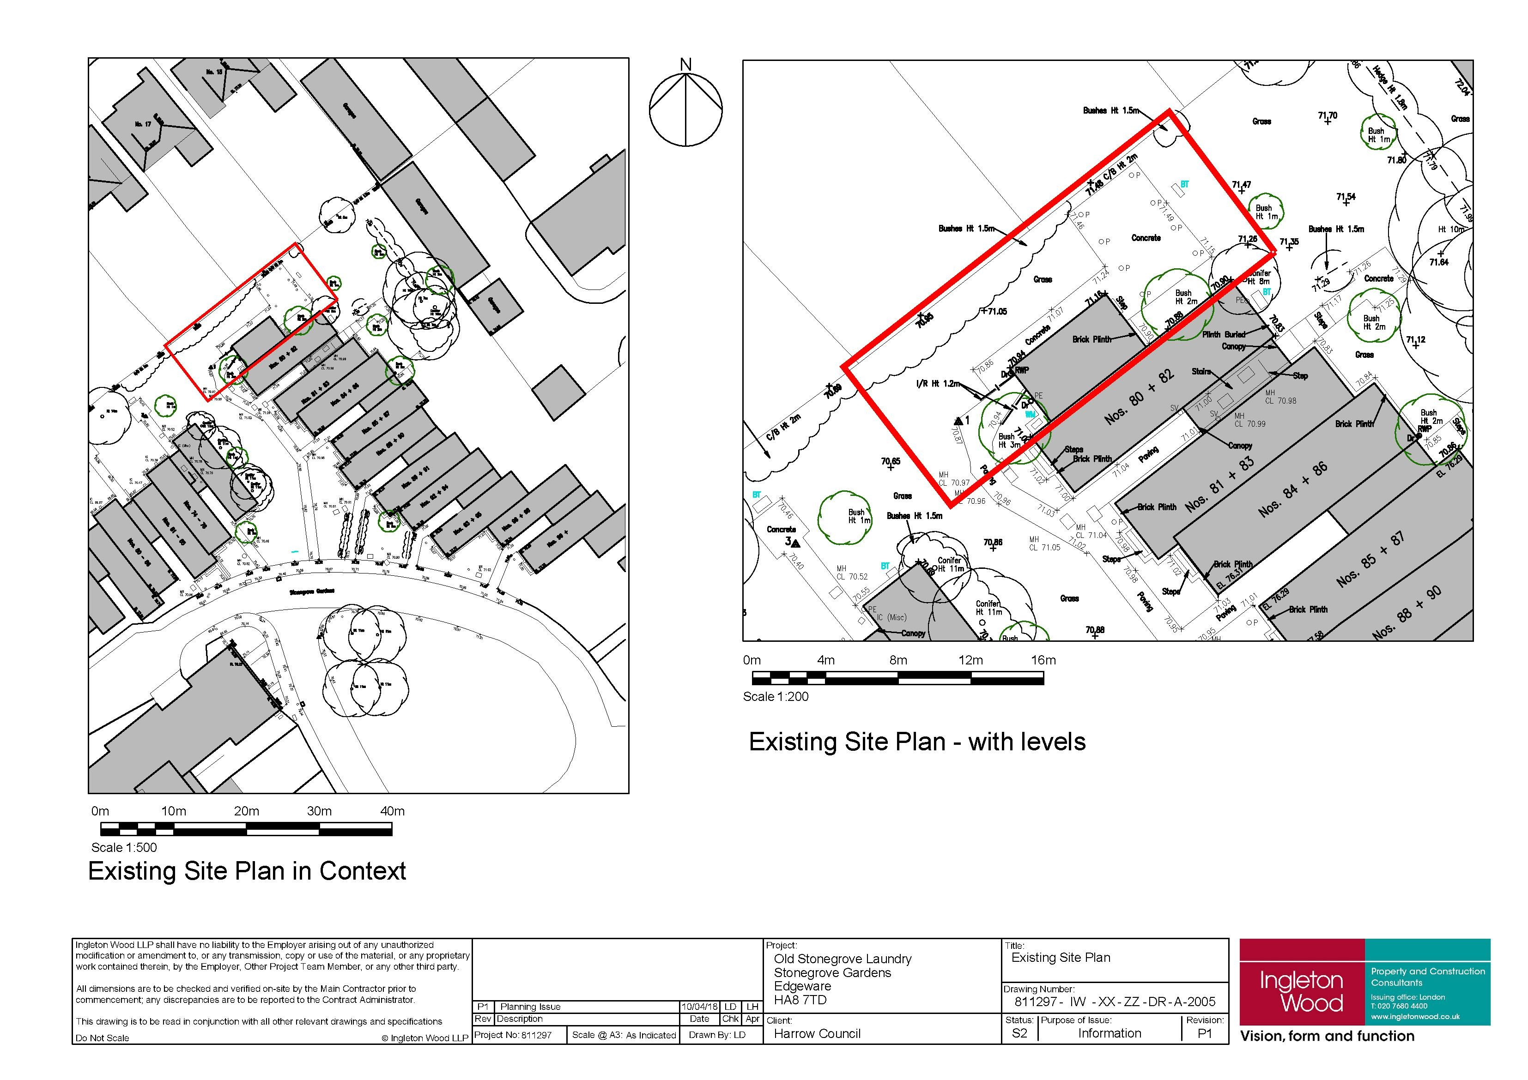
APPENDIX 3: SITE PHOTOGRAPHS

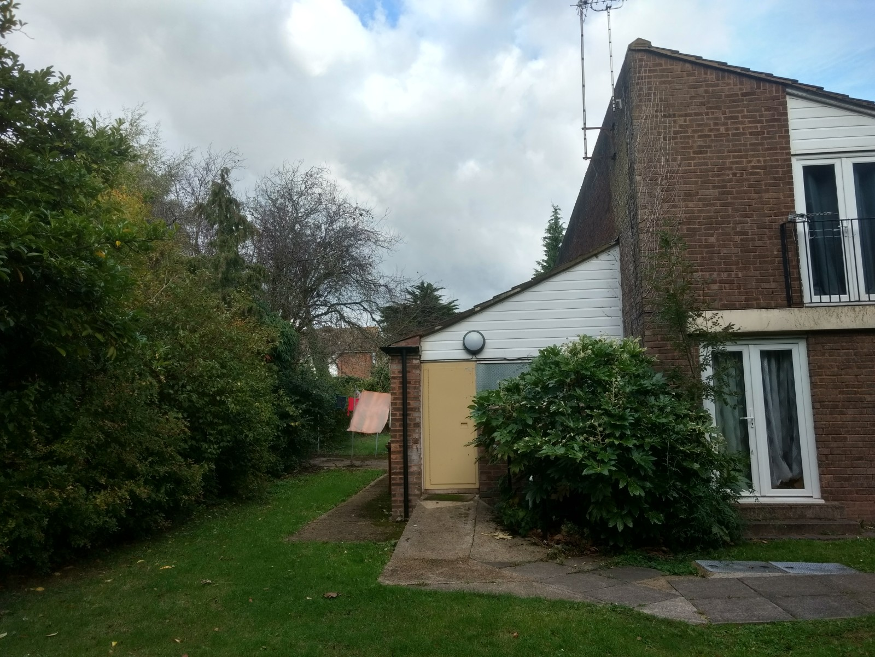

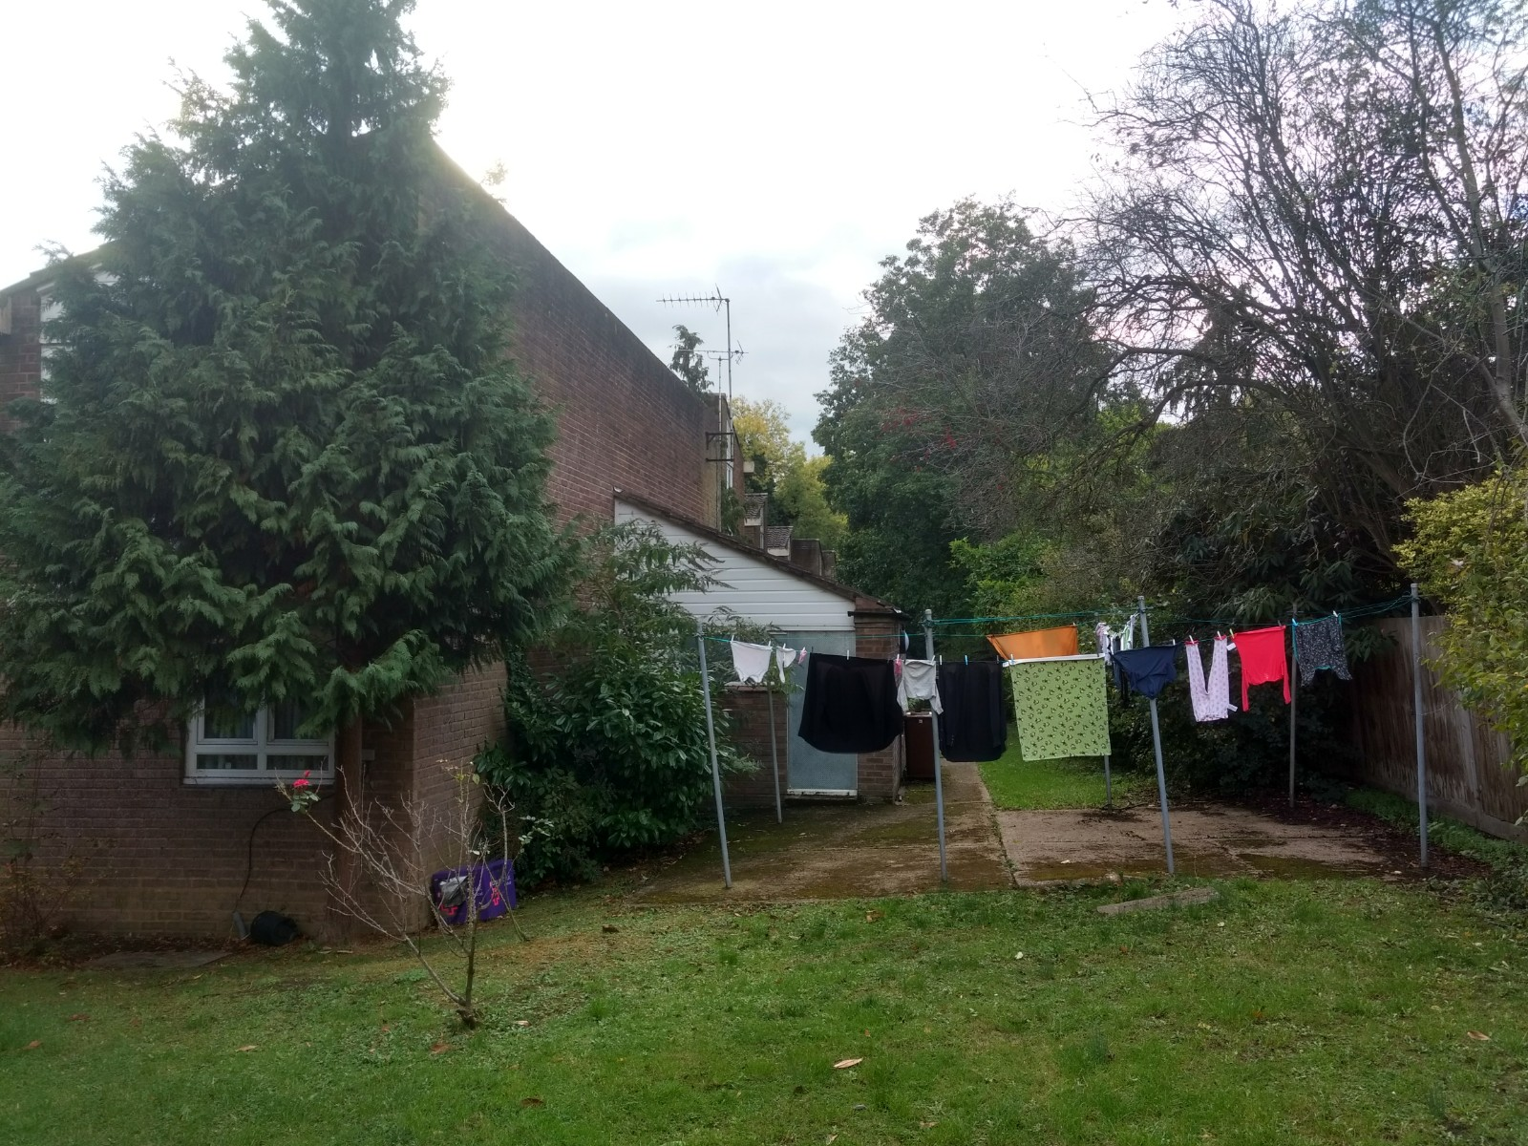

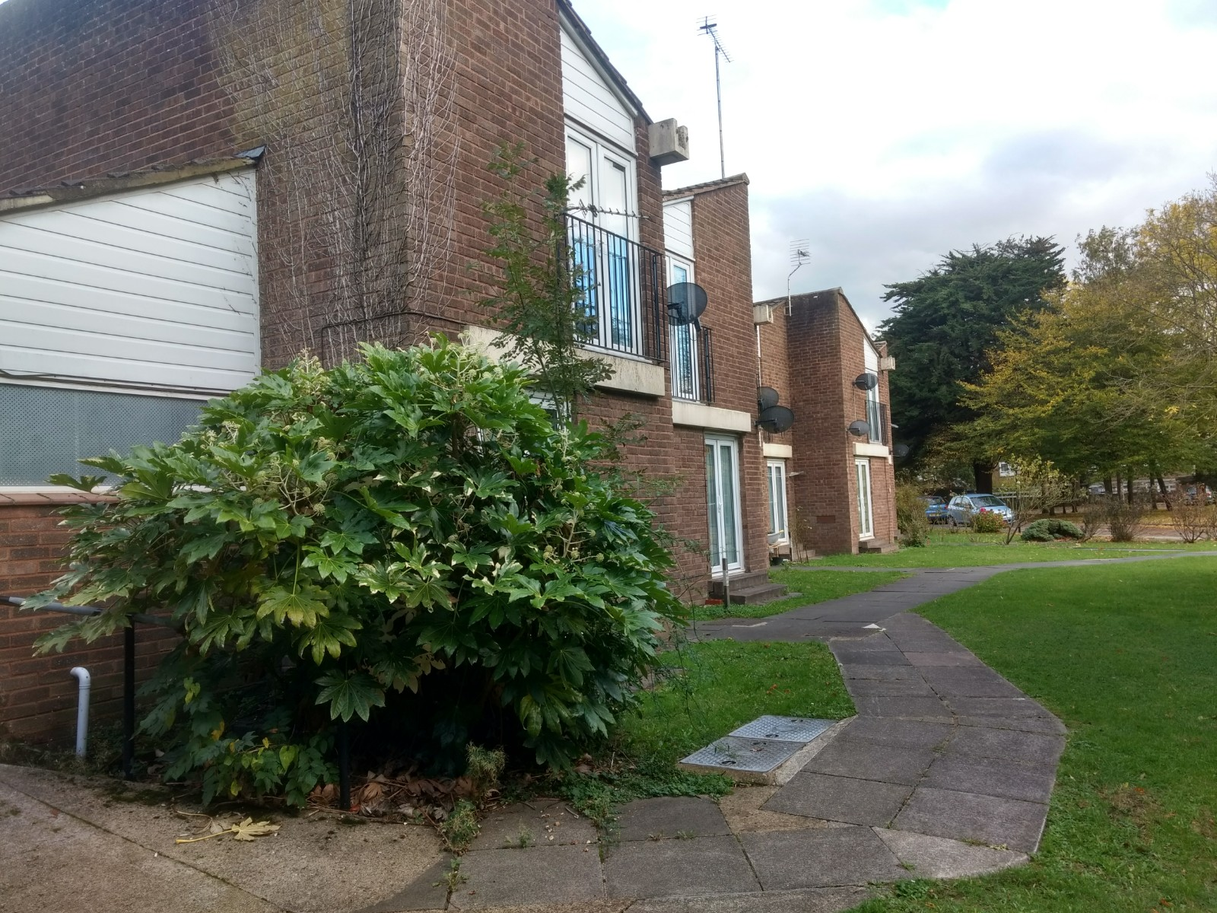

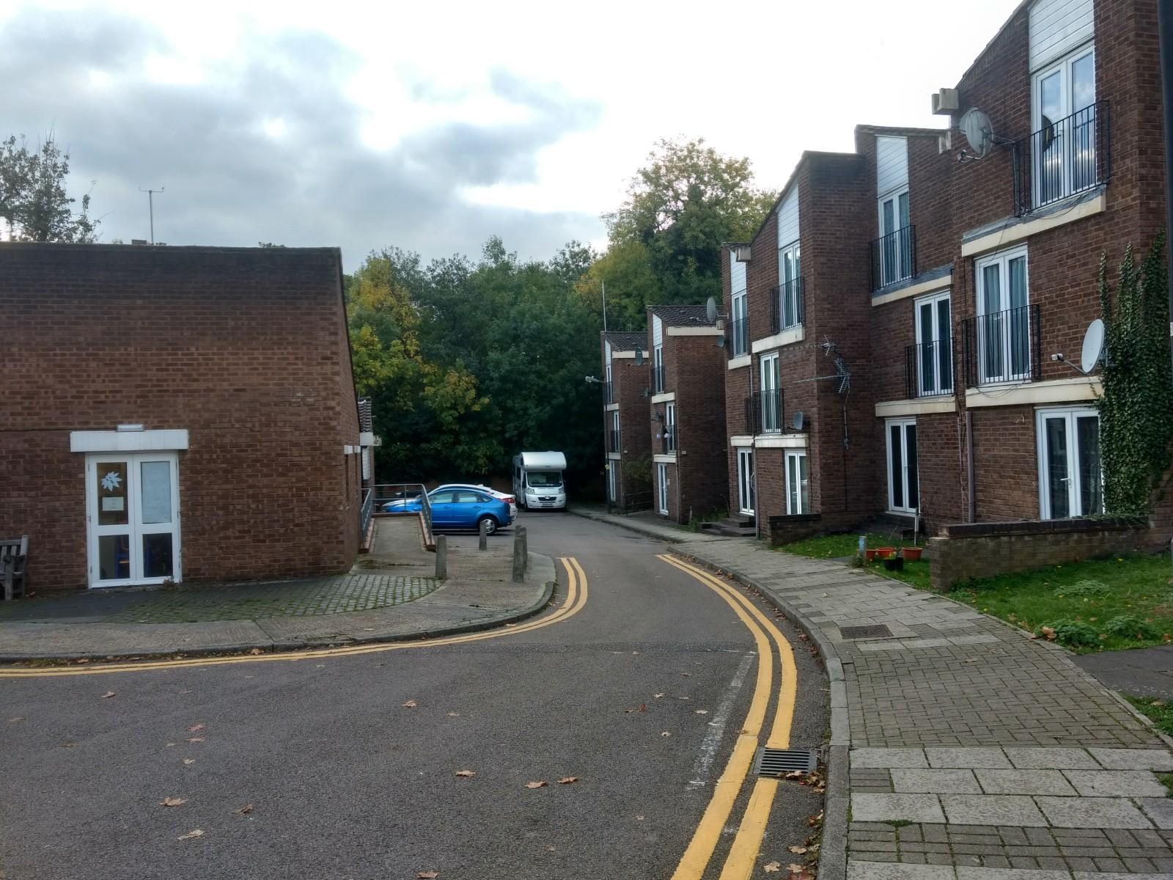

APPENDIX 4: PLANS AND ELEVATIONS

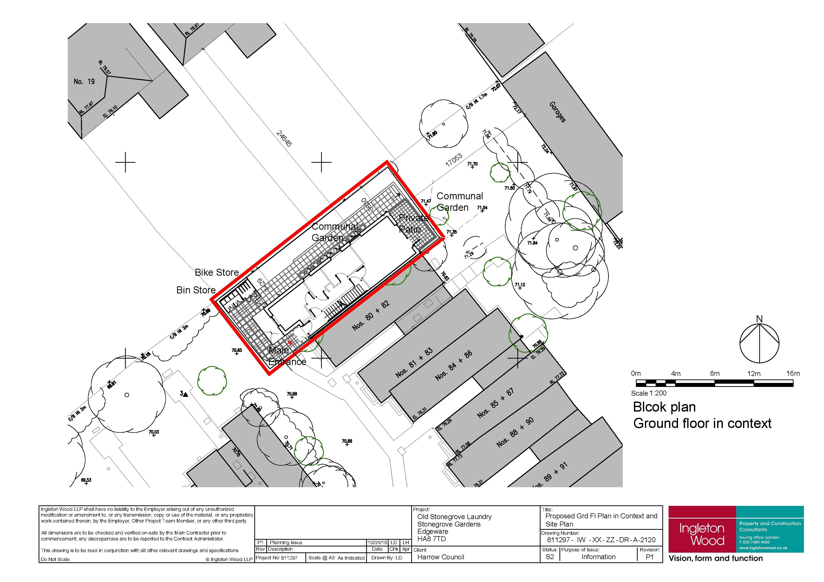

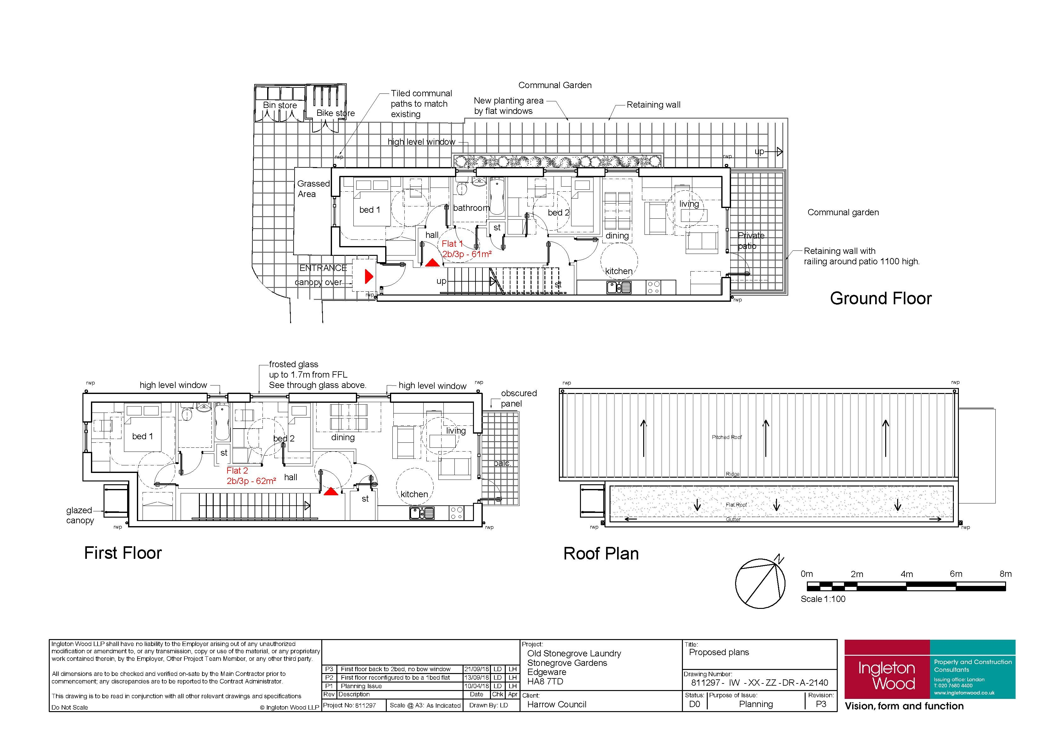

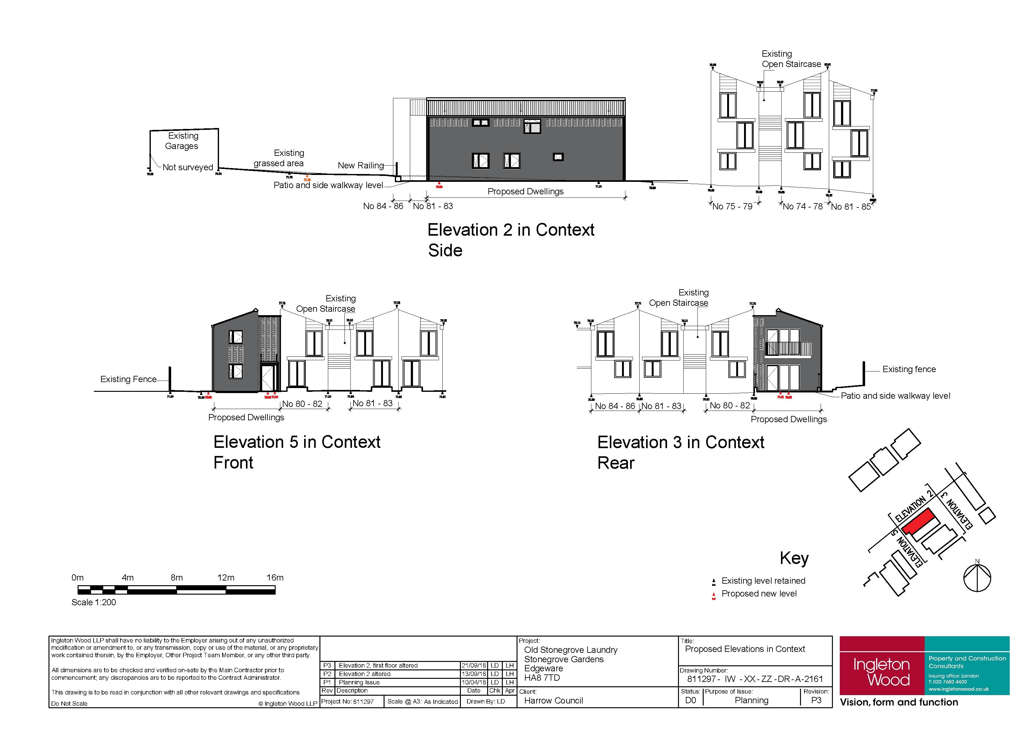

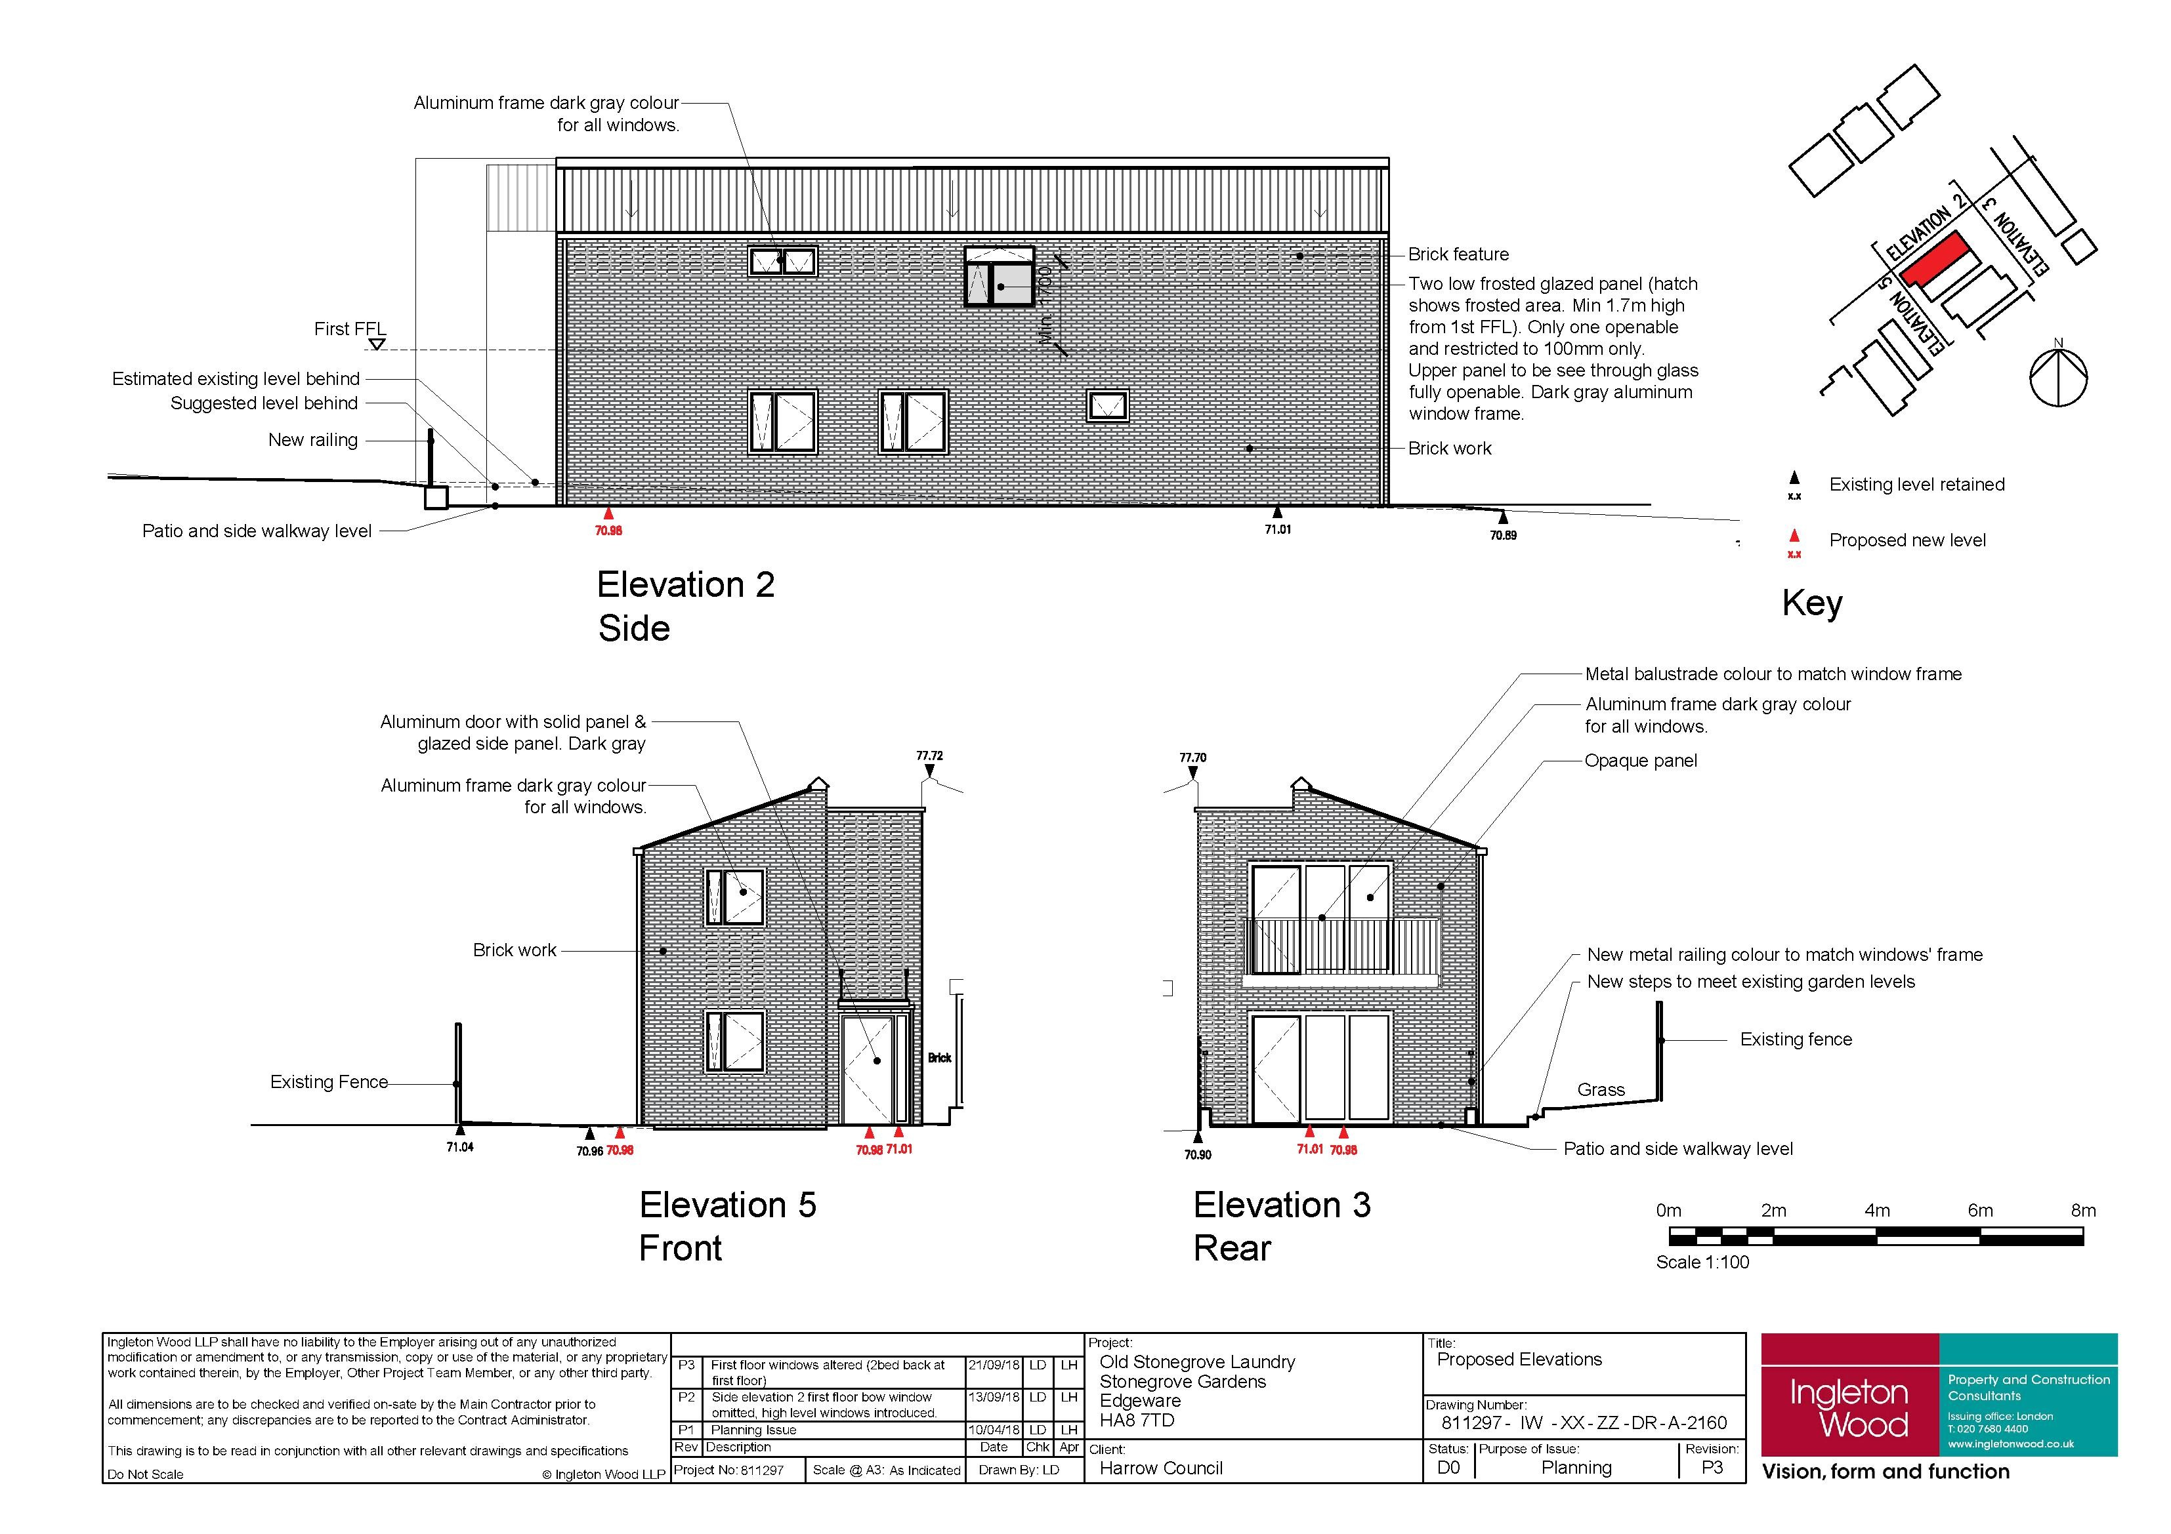

This page has been left intentionally blank

